

**Design and Implementation**

**of**

**Mini Operating System Simulator**

**Submitted by:**

**Meher Sultan Khan**

**Abdul Ahad**

**Jan 2026**

**Introduction**

This report documents the design and implementation of a Mini Operating System Simulator developed as part of the Complex Computing Problem (CCP) for Operating Systems Lab. The simulator integrates three fundamental operating system concepts: process scheduling, concurrent process management through producer-consumer mechanisms, and deadlock prevention using resource allocation strategies.

The simulator is implemented in C++ using modern threading libraries (pthread) and semaphore-based synchronization primitives. It provides a command-line interface that allows users to interact with the system, observe scheduling decisions, monitor process creation and consumption, and verify safe resource allocation states.

**System Architecture**

**The simulator consists of three cooperating modules that work together to create a realistic operating system environment:**

* **Part A:** Process Scheduler Module - Implements Priority Scheduling and Round Robin algorithms with automatic selection based on ready queue size
* **Part B:** Producer-Consumer Module - Simulates concurrent process creation using multiple producer threads and consumer threads with semaphore-based synchronization
* **Part C:** Banker's Algorithm Module - Prevents deadlock by ensuring the system never enters an unsafe state through resource allocation checking

**Process Structure**

Figure.1 shows the Process data structure that forms the foundation of our simulator. Each process contains all necessary attributes for scheduling, resource management, and statistics collection:

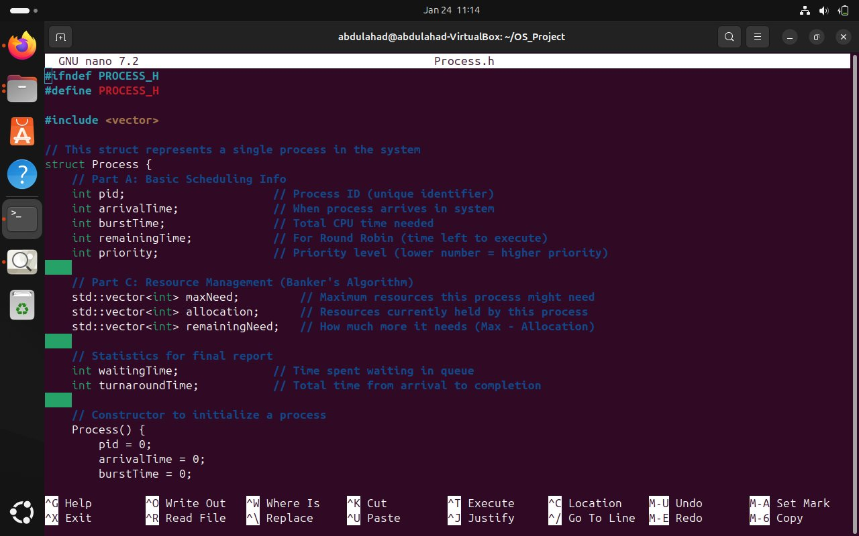

***Figure 1: Process.h - Complete Process Data Structure***

**The Process structure includes:**

* **Basic Scheduling Info:** Process ID (pid), arrival time, CPU burst time, remaining time for preemption, and priority level
* **Resource Management:** Three vectors (maxNeed, allocation, remainingNeed) that implement the Banker's Algorithm requirement for tracking resource requirements
* **Statistics:** Waiting time and turnaround time for performance analysis

This design ensures each process carries all information needed for scheduling decisions, resource allocation checks, and final statistical reporting.

**Part A: Process Scheduler Module**

The scheduler module implements two classical CPU scheduling algorithms: Priority Scheduling (non-preemptive) and Round Robin (preemptive). The system automatically selects the appropriate algorithm based on the number of processes in the ready queue.

**Scheduler Interface Design**

Figure 2 presents the Scheduler class interface defined in Scheduler.h, which encapsulates all scheduling functionality:

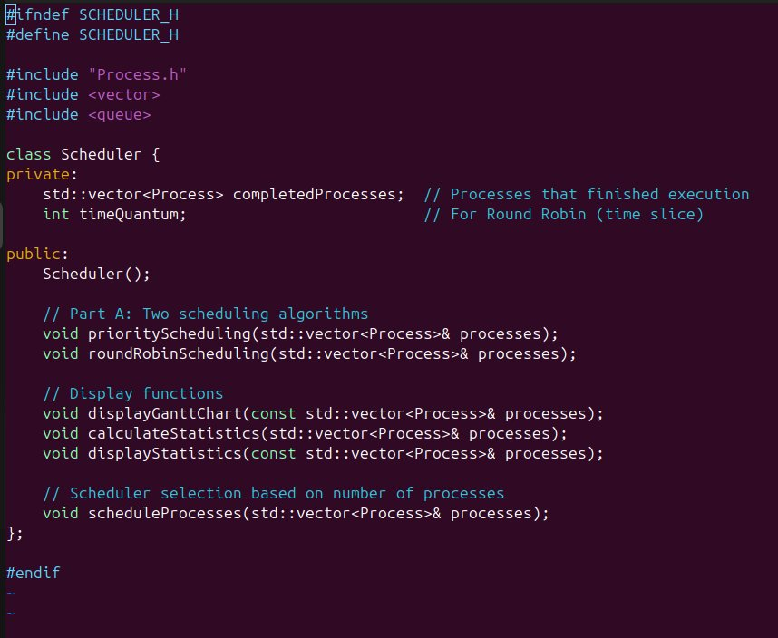

***Figure 2: Scheduler.h - Interface Design and Function Declarations***

**The Scheduler class provides clean separation of concerns with distinct methods for:**

* priorityScheduling() - Executes non-preemptive priority-based scheduling
* roundRobinScheduling() - Executes preemptive time-slice-based scheduling
* scheduleProcesses() - Automatic algorithm selection based on ready queue size
* Display functions for Gantt chart visualization and statistical reporting

**Automatic Scheduler Selection Logic**

The most critical component of the scheduler is the automatic selection mechanism. As specified in the CCP requirements, the system must choose between Priority Scheduling and Round Robin based on the number of ready processes. Figure 3 demonstrates this decision logic:

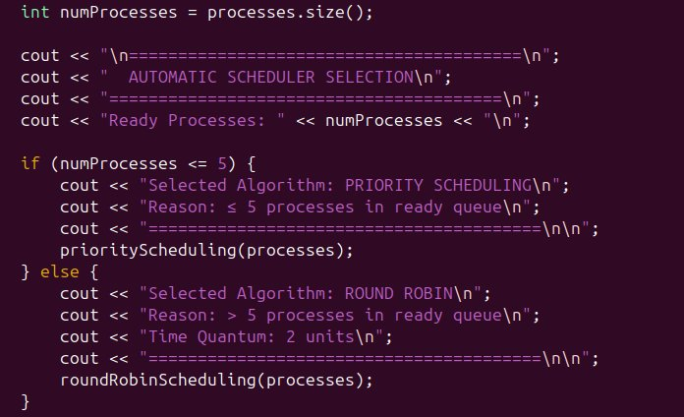

***Figure 3: Automatic Scheduler Selection - Priority (≤5) vs Round Robin (>5)***

**The scheduleProcesses() function implements the following logic:**

1. Counts the number of ready processes in the queue
2. If ≤ 5 processes: Selects Priority Scheduling for better response time with low load
3. If > 5 processes: Selects Round Robin to ensure fairness and prevent starvation
4. Displays clear reasoning for the algorithm selection to the user

This dynamic selection ensures optimal scheduling behavior: Priority Scheduling provides efficient execution for smaller workloads, while Round Robin prevents monopolization and ensures fairness when the system becomes heavily loaded.

**Scheduler Implementation**

Figure 4 shows the core implementation of the scheduling algorithms in Scheduler.cpp:

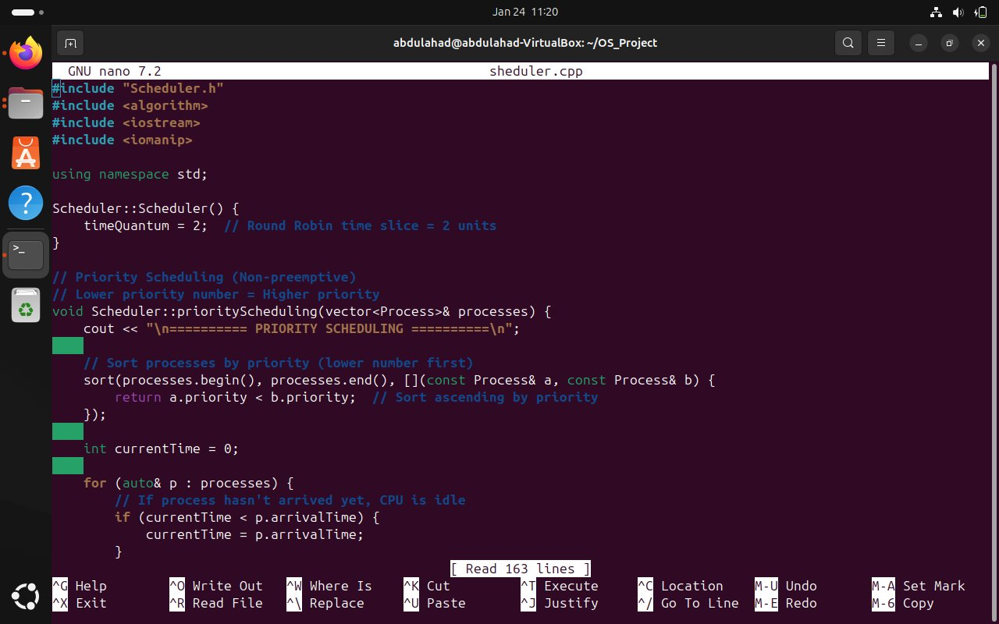

***Figure 4: Scheduler.cpp - Priority and Round Robin Algorithm Implementations***

**Key implementation details:**

* **Priority Scheduling:** Processes are sorted by priority (lower number = higher priority), then executed to completion in non-preemptive fashion
* **Round Robin:** Time quantum set to 2 units, with processes cycling through the ready queue until all are completed
* Both algorithms track waiting time, turnaround time, and generate execution traces for the Gantt chart

**Scheduling Output and Statistics**

Figure 5 demonstrates the complete output from a Round Robin scheduling execution with 6 processes:

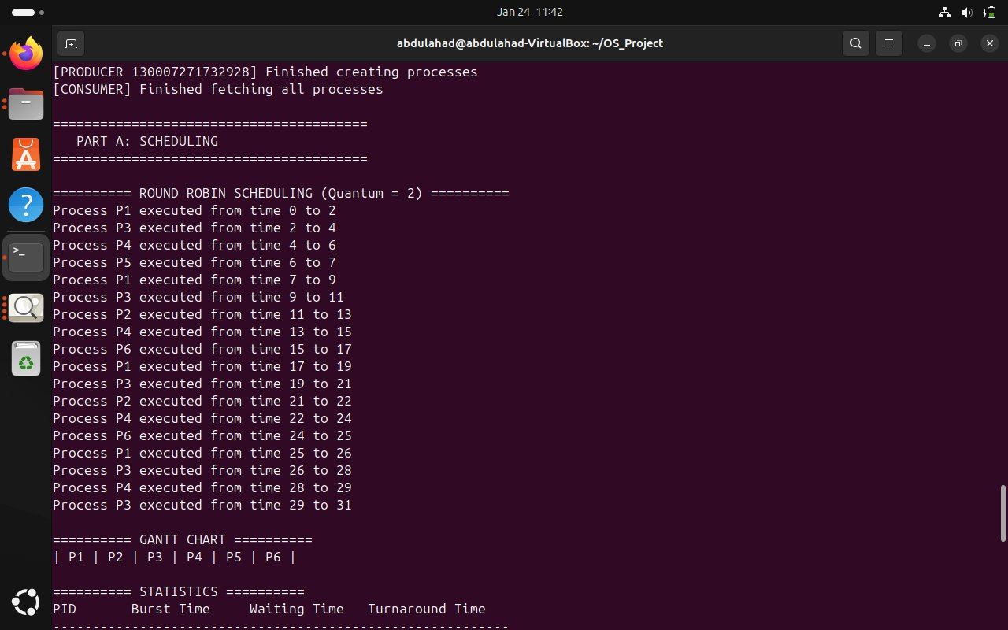

***Figure 5: Round Robin Scheduling Output - Gantt Chart and Performance Statistics***

**The output includes:**

* Execution trace showing each process's time slices and context switches
* Text-based Gantt chart visualizing the scheduling timeline
* Detailed statistics table showing burst time, waiting time, and turnaround time for each process
* Average Waiting Time: 14.5 time units and Average Turnaround Time: 19.67 time units

**Part B: Producer-Consumer Module**

The Producer-Consumer module simulates concurrent process creation and consumption using POSIX threads and semaphore-based synchronization. This module demonstrates how processes dynamically enter the operating system and are dispatched to the CPU scheduler.

**Shared Buffer and Synchronization Structure**

Figure 6 shows the ProducerConsumer.h header file, which defines the shared buffer structure and synchronization primitives:

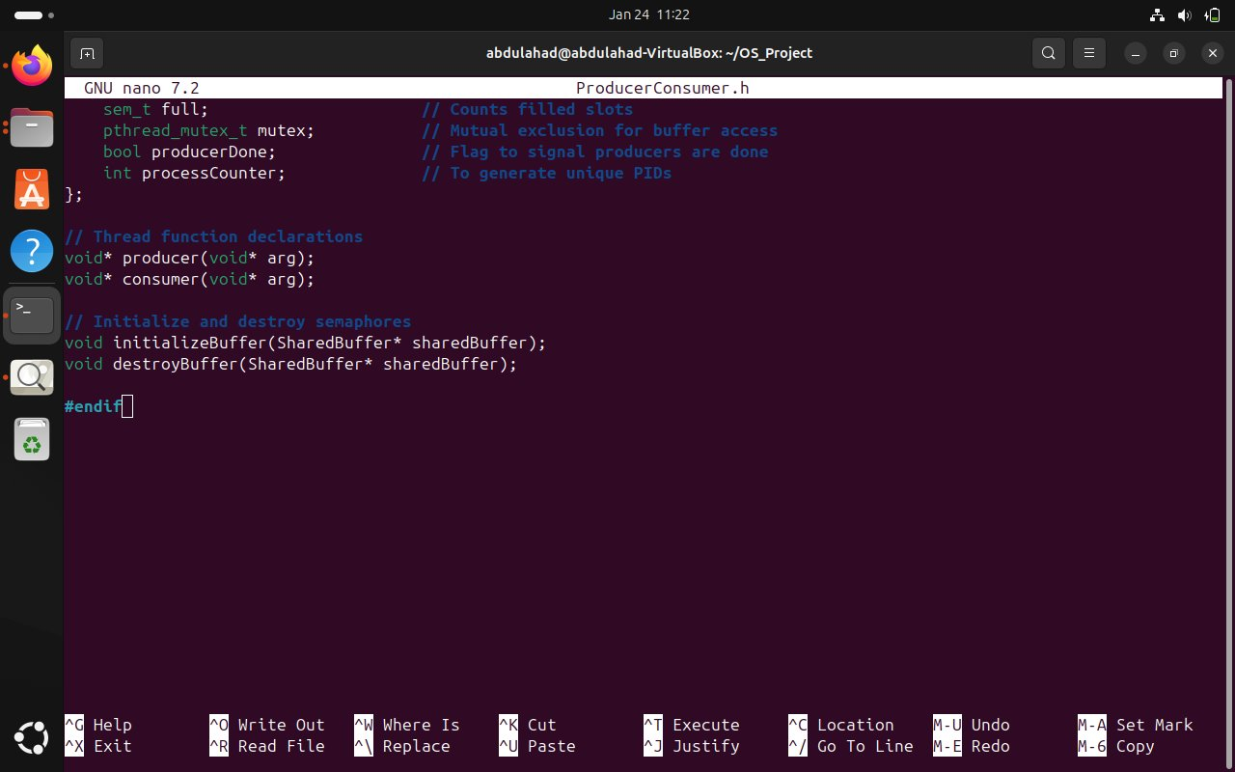

***Figure 6: ProducerConsumer.h - Shared Buffer Structure with Semaphores and Mutex***

**The SharedBuffer structure contains:**

* Buffer array and size tracking for the bounded buffer implementation
* Semaphore 'empty' - Counts available slots (initialized to BUFFER_SIZE)
* Semaphore 'full' - Counts filled slots (initialized to 0)
* Mutex for mutual exclusion during buffer access
* Control flags (producerDone) and process counter for unique PID generation

**Semaphore Initialization and Synchronization Logic**

Figure 7 demonstrates the critical semaphore initialization in ProducerConsumer.cpp:

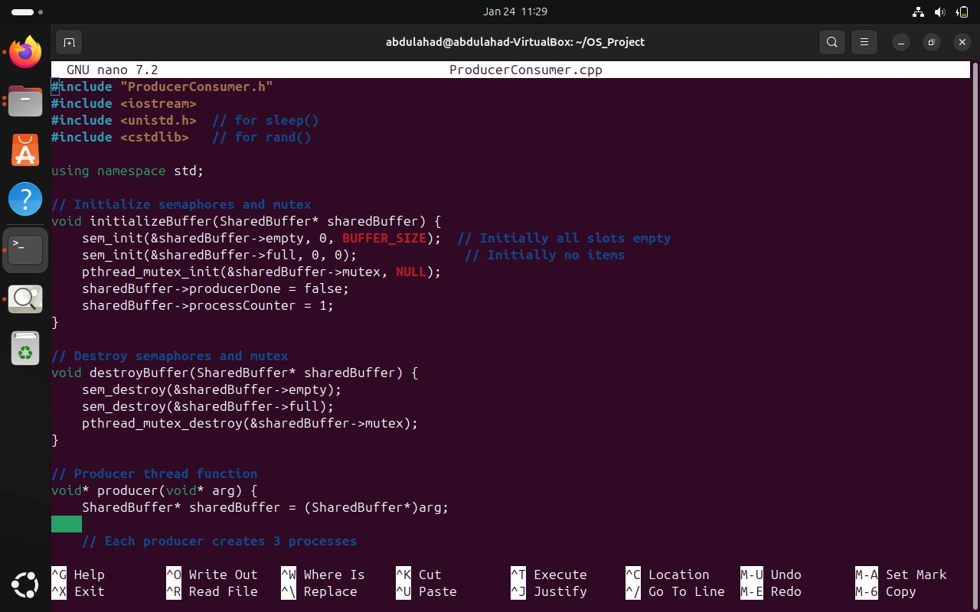

***Figure 7: ProducerConsumer.cpp - Semaphore Initialization and Thread Functions***

**The initializeBuffer() function sets up proper synchronization:**

* sem_init(&empty, 0, BUFFER_SIZE) - Initially all slots are empty and available
* sem_init(&full, 0, 0) - Initially no items are in the buffer
* pthread_mutex_init() - Ensures mutual exclusion for critical sections

The producer thread creates processes and inserts them into the buffer, while the consumer thread fetches processes and sends them to the scheduler. Semaphores prevent race conditions and ensure the buffer never overflows or underflows.

**Producer-Consumer Execution Output**

Figure 8 shows the execution trace of the producer-consumer system with 2 producer threads and 1 consumer thread:

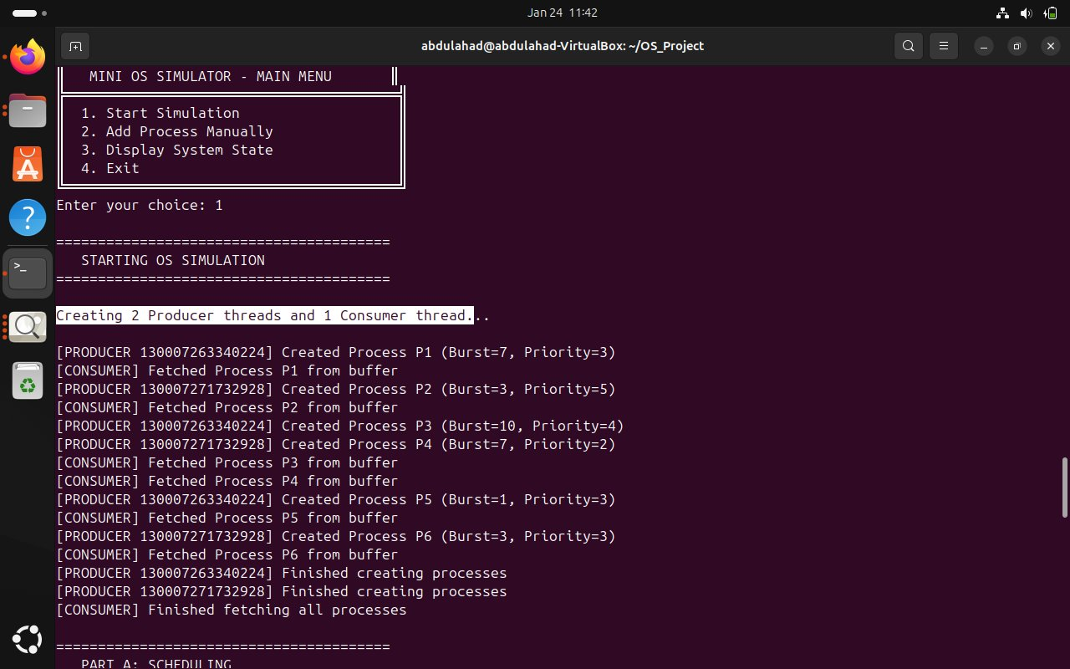

***Figure 8: Producer-Consumer Execution - Thread Creation and Process Flow***

**The execution trace demonstrates:**

* Two producer threads (IDs: 130007263340224 and 130007271732928) creating processes concurrently
* Each producer creates 3 processes with varying burst times and priorities
* Consumer thread fetching processes from the buffer in the order they arrive
* Proper synchronization ensures no buffer overflow or underflow
* Total of 6 processes (P1-P6) successfully created and transferred to the scheduler

This concurrent process generation simulates realistic operating system behavior where multiple sources (user applications, system services) create processes simultaneously, and the OS must manage them safely and efficiently.

**Part C: Banker's Algorithm Module**

The Banker's Algorithm module implements deadlock prevention by ensuring the system never enters an unsafe state. Before executing any process, the system checks whether granting its resource requirements would maintain system safety.

**Banker's Algorithm Implementation**

Figure 9 shows the implementation of the safety check algorithm in BankersAlgorithm.cpp:

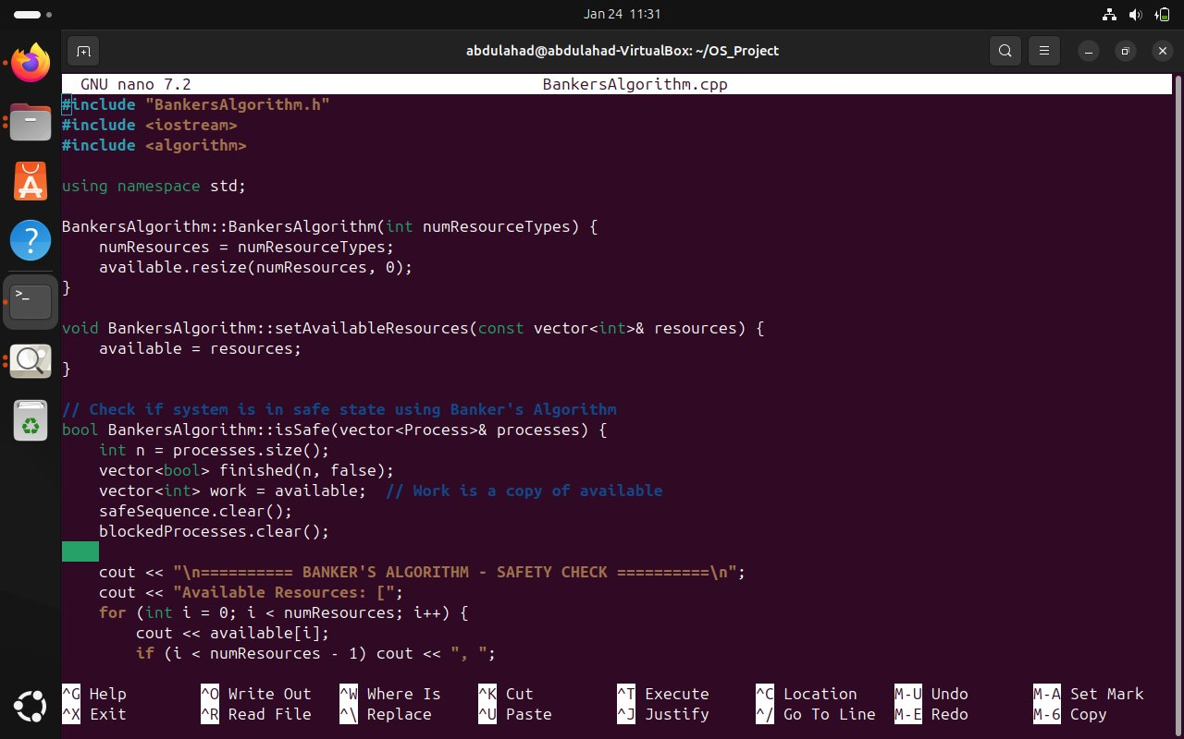

***Figure 9: BankersAlgorithm.cpp - Safety Check Implementation***

**The isSafe() function implements the classical Banker's Algorithm:**

1. Initialize work vector as a copy of available resources
2. Mark all processes as unfinished
3. Iteratively find processes whose remaining needs can be satisfied by available resources
4. If such a process is found, assume it completes and releases its allocated resources back to the system
5. Continue until all processes finish (SAFE) or no more progress can be made (UNSAFE)

**Safe State Verification**

Figure 10 demonstrates a successful safe state check with 6 processes and available resources [10, 10, 10]:

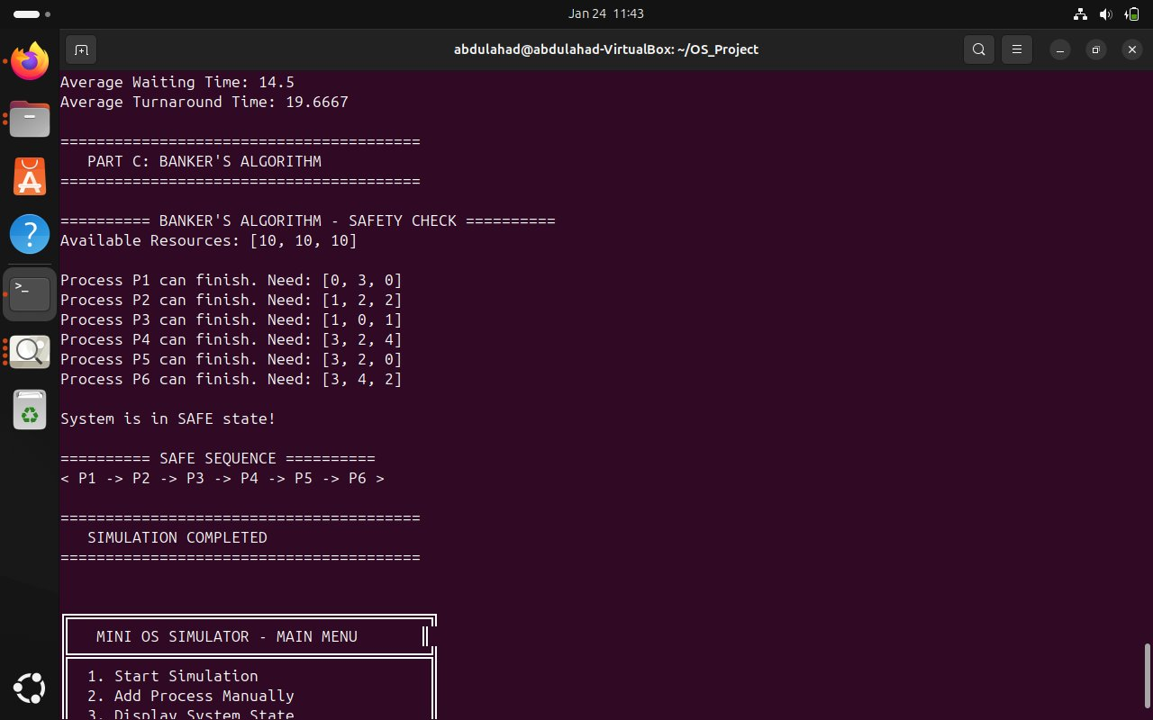

***Figure 10: Banker's Algorithm - Safe State with Safe Sequence***

**The safe state output shows:**

* Available resources: [10, 10, 10] across 3 resource types
* Each process's remaining need vector (difference between max need and current allocation)
* System is in SAFE state confirmation
* Safe sequence: P1 → P2 → P3 → P4 → P5 → P6

This safe sequence guarantees that even if all processes request their maximum resources, the system can satisfy them one by one without deadlock.

**Unsafe State and Blocked Process Handling**

Figure 11 demonstrates the system's behavior when a process would create an unsafe state. Process P999 with extremely high resource requirements [50, 50, 50] is blocked to prevent deadlock:

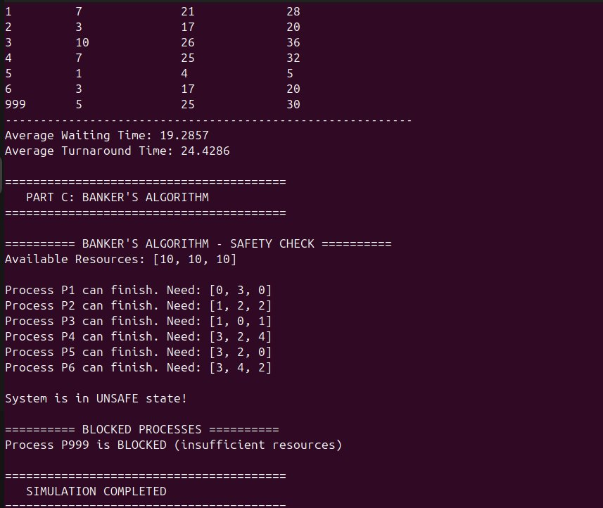

*Figure 11: Banker's Algorithm - Unsafe State Detection and Process Blocking*

**The unsafe state handling demonstrates:**

* Safety check detects that processes P1-P6 can still complete with available resources
* Process P999 requesting [50, 50, 50] cannot be satisfied without creating deadlock risk
* System correctly identifies 'System is in UNSAFE state!' condition
* Process P999 is BLOCKED and queued, preventing system from entering deadlock

This proactive blocking mechanism is the core of deadlock prevention. Rather than allowing the system to enter an unsafe state and potentially deadlock, the Banker's Algorithm ensures only safe resource allocations proceed. Blocked processes remain in queue until resources become available and their allocation would maintain safety.

**System Integration**

The three modules work together as an integrated simulation system through the main control program and build system.

**Main Control Program**

Figure 12 shows the main.cpp file which orchestrates all three modules and provides the user interface:

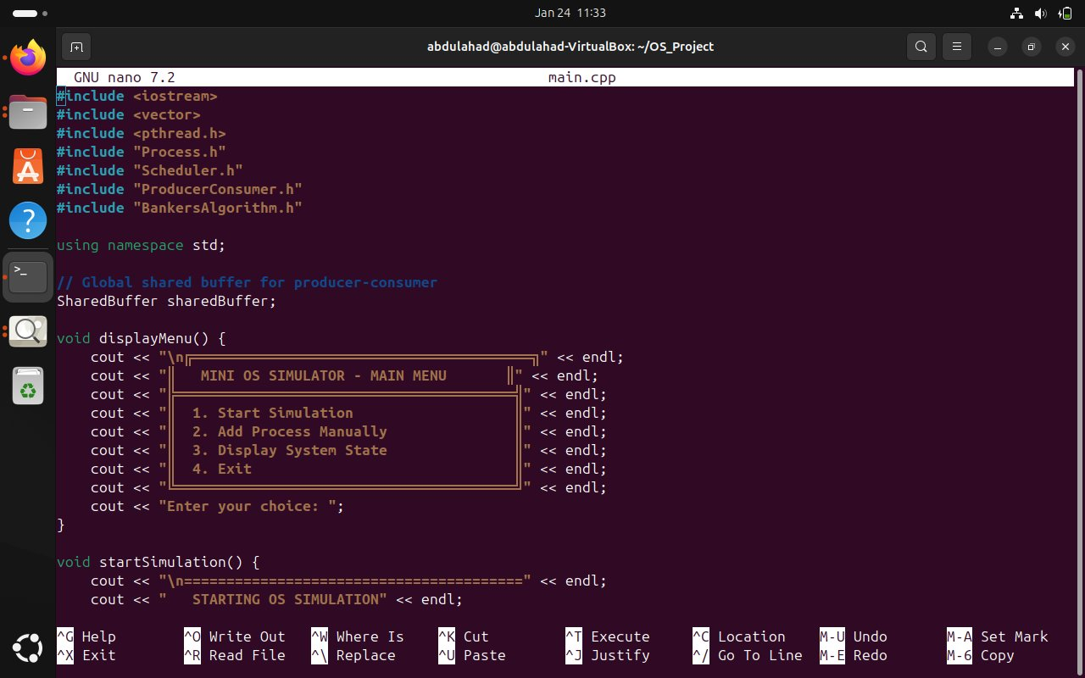

*Figure 12: main.cpp - Menu System and Module Integration*

**The main program provides:**

* Menu-based interface with options: Start Simulation, Add Process Manually, Display System State, Exit
* Global shared buffer for producer-consumer coordination
* startSimulation() function that orchestrates all three parts sequentially
* Clean separation between Part A (Scheduling), Part B (Producer-Consumer), and Part C (Banker's Algorithm)

**Build System**

Figure 13 shows the Makefile that compiles all modules with proper dependencies and flags:

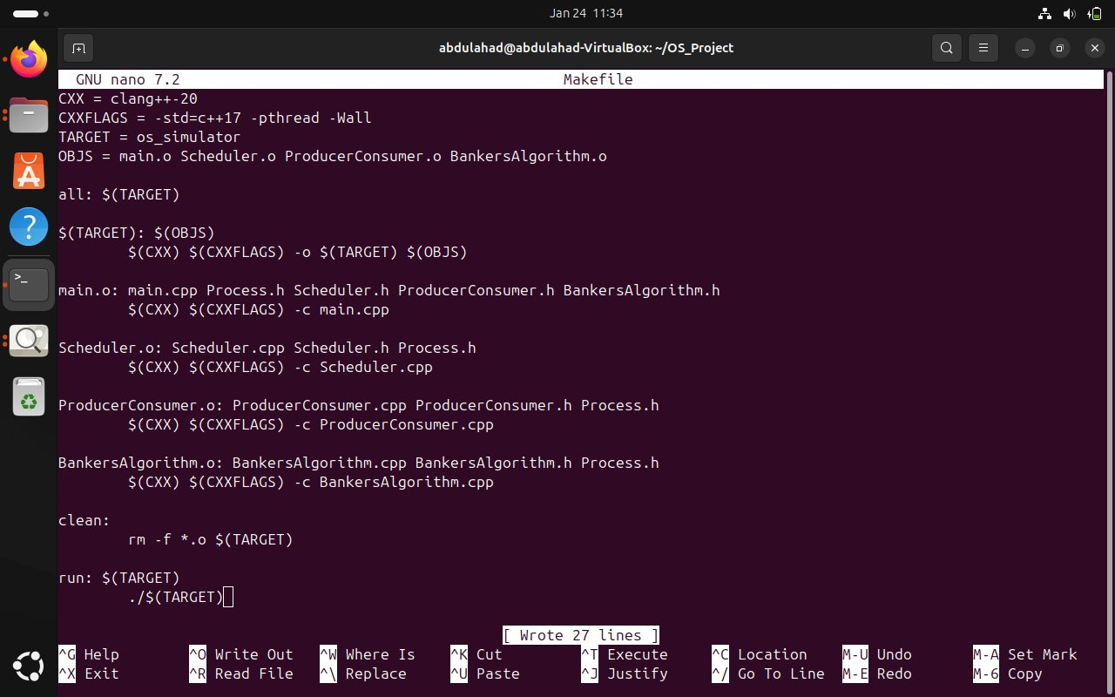

***Figure 13: Makefile - Modular Build System with Threading Support***

**The build system demonstrates:**

* Compiler: clang++-20 with C++17 standard
* Flags: -pthread for POSIX threading support, -Wall for comprehensive warnings
* Modular compilation: Separate object files for each module (main.o, Scheduler.o, ProducerConsumer.o, BankersAlgorithm.o)
* Clean target for easy recompilation and run target for convenient execution

**Limitations and Future Enhancements**

**Current Limitations**

While the simulator successfully demonstrates core operating system concepts, several limitations exist in the current implementation:

* Fixed Resource Types: The system uses exactly 3 resource types, which limits flexibility for different scenarios
* Simulated Execution: Process execution is simulated through delays rather than actual code execution
* Limited Scheduling Algorithms: Only Priority and Round Robin are implemented; other algorithms like FCFS, SJF, or Multilevel Queue could enhance the system
* No Dynamic Priority Adjustment: The simulator doesn't implement aging or dynamic priority mechanisms to prevent starvation
* Command-Line Interface Only: No graphical visualization of process states, scheduling timelines, or resource allocation matrices
* Limited Error Handling: Some edge cases (invalid user input, extreme resource requests) may not be fully validated

**Potential Enhancements**

**The following enhancements could extend this simulator into a Final Year Project (FYP):**

1. GUI Development: Create a graphical interface with real-time visualization of process states, Gantt charts, and resource allocation matrices
2. Additional Scheduling Algorithms: Implement FCFS, SJF, SRTF, Multilevel Queue, and Multilevel Feedback Queue for comparative analysis
3. Memory Management: Add paging, segmentation, and virtual memory simulation
4. File System Simulation: Implement basic file operations, directory structures, and I/O scheduling
5. Distributed Systems: Extend to multi-node simulation with message passing and distributed scheduling
6. Performance Metrics: Add detailed performance analysis, comparison charts, and algorithm efficiency studies
7. Container Orchestration: Extend to simulate Docker-like container scheduling and resource allocation
8. Real-Time Scheduling: Implement EDF, Rate Monotonic, and other real-time scheduling algorithms

# **Conclusion**

This Mini Operating System Simulator successfully integrates three fundamental operating system concepts into a cohesive, working system. The implementation demonstrates understanding of CPU scheduling algorithms, concurrent programming with proper synchronization, and deadlock prevention through resource allocation strategies.

**Key achievements of this project include:**

* Automatic scheduler selection that optimizes performance based on system load
* Proper semaphore-based synchronization preventing race conditions in concurrent process creation
* Proactive deadlock prevention through the Banker's Algorithm safety checks
* Clean modular architecture that separates concerns and enables future extension
* Comprehensive output providing detailed insights into scheduling decisions and system behavior

The simulator provides a solid foundation for understanding operating system internals and serves as an excellent base for future expansion. By implementing the suggested enhancements, this project could evolve into a comprehensive OS simulation platform suitable for educational purposes, research, or as a Final Year Project demonstrating advanced system programming skills.

Through this project, key lessons were learned about the importance of proper synchronization in concurrent systems, the trade-offs between different scheduling algorithms, and the critical role of resource management in preventing deadlock. The experience gained in designing and implementing this simulator provides valuable preparation for future work in systems programming, d**istributed computing, and operating system development.**

***--- End of Report ---***